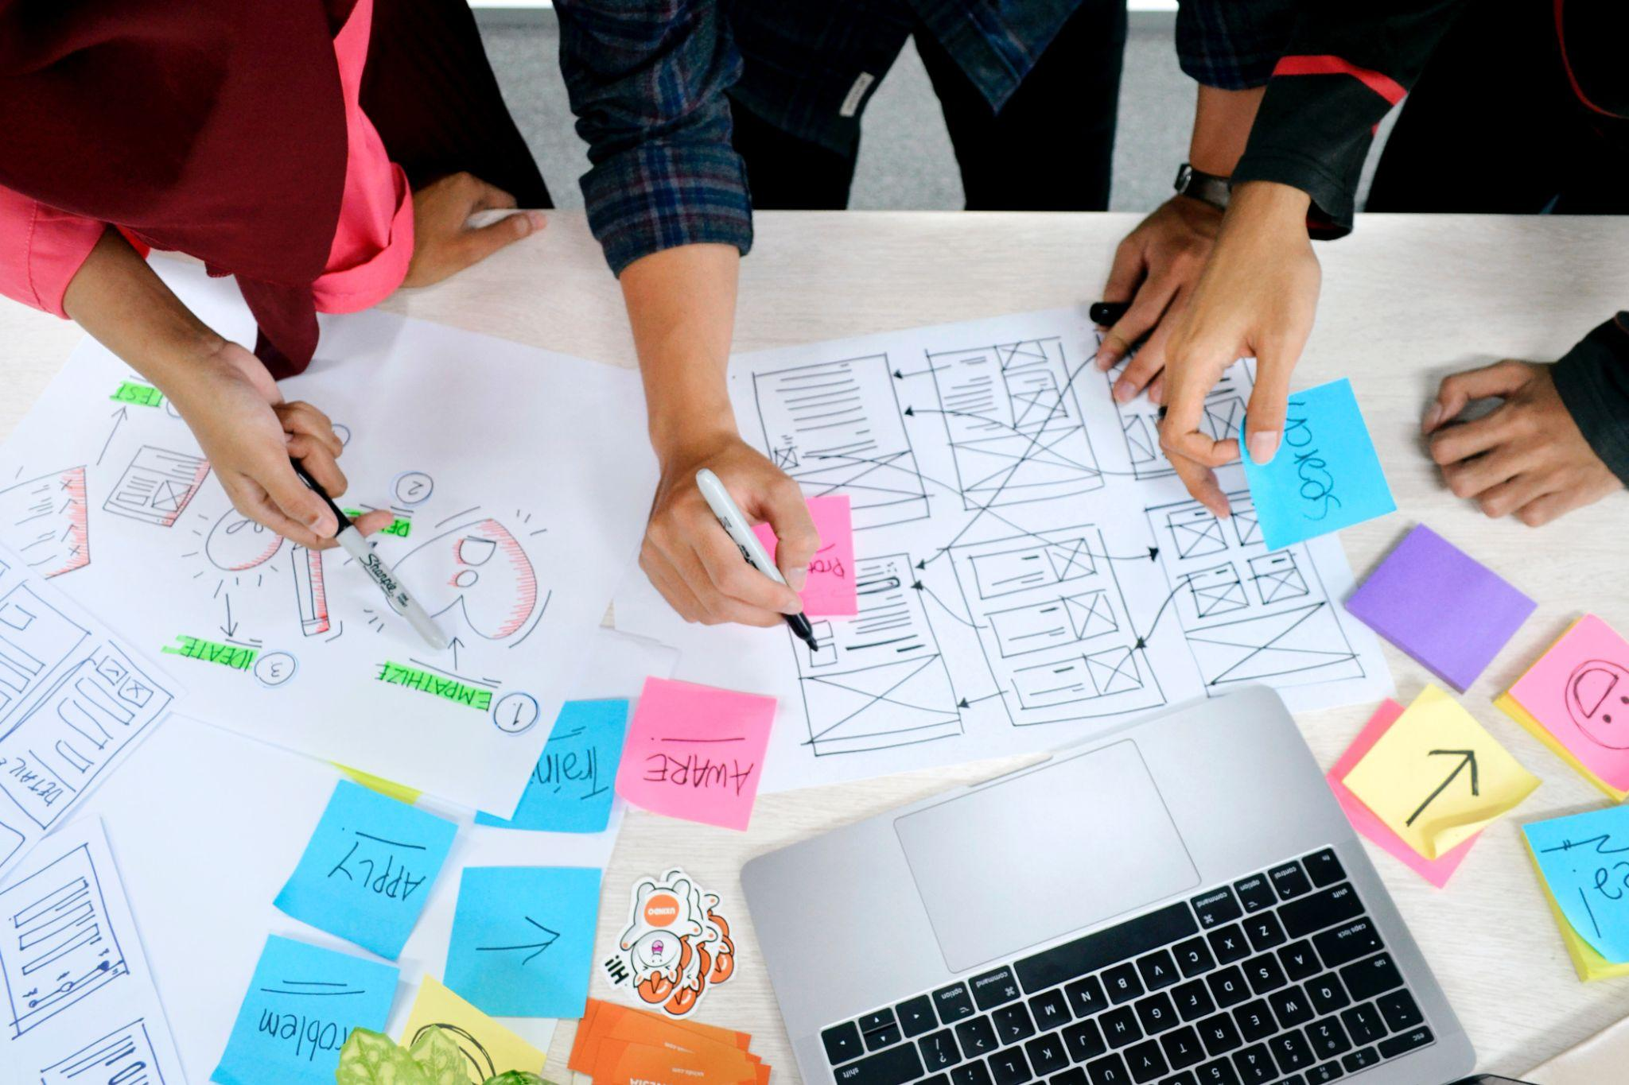

Project Concept

International Week Group Project

Group: 1

Date: 09/05/2023

Team: Tudor, Anastasia, Paulina, Jenny, Fabio, Kun, Erick, Hubert, Harun, Emilija

# Introduction

This document will contain our research and the results of our labour.

Table of content

**Introduction 2**

**Concept 4**

Target audience 4

Interviews 5

Interview conclusions 5

Persona’s 7

User stories 8

**App design 8**

**Building design 10**

# Concept

With the broad target audience in mind we have come up with a couple of ideas with similar end results.  
As described in the assignment, Vestide wants us to create an interactive tool for students to share their ideas of what the core values mean to them and to display them in some form.

Humans tend to understand information much faster when it is visual instead of written. Our idea was to render a visual image of their ideas by using AI generated images.  
We gather the information on what the core values mean by sending surveys to the students going to the campus.

After generating all the visuals with AI, the output will be used to display it throughout the campus.

At a later stage, students will be able to share their ideas through an app that will eventually reward them with a coupon for a discount at the school café so they will be motivated to share their ideas.

In the future there could be a café where students can see the artworks whilst enjoying a cup of coffee and discuss it with other students or vote and share their favourite artworks.

## Target audience

An important step for this project is to know who our end-users are. We discussed this with our stakeholder who works for Vestide. Vestide wants to create this community for the students of the TU/e campus including the ones who are part of Fontys studying there.

During the kick-off presentation it was mentioned that this community is meant to bring people closer to each other and make it easier to socialise with new people.

This makes our target audience broad and complicated to narrow down to a specific group of people.

With this in mind we plan to develop a solution that will be applicable to a large variety of students.

## 

## Interviews

All participants of this interview are from the Fontys UAS

**Q:** How would you like to express your ideas for these core values? (for instance: digital or analog)

**P1:** *Since I use my phone on a daily basis, I would like to do it through my phone, this would be the easiest way for me to do it.*

**P2:** *I use my phone a lot so probably through an app or a website, something I can do from my phone works for me.*

**P3:** *I like these core values, most I like are arms wide open as it is open minden and makes you feel accepted. I would like to see them represented in a digital way, because as a student I am used to see things mainly in a screen*

**P4:** *I would like to express them digitally, preferably in a space, where other people can see it*

**Q:** How would you like your ideas for the core values to be displayed? (for instance: visual art/text)

**P1:** *I find visual art more appealing than text, text can be boring and it wouldn't grab my attention as much as visual art.*

**P2:** *Definitely visual art, I like text too, but something that is colourful takes my attention much easier than text.*

**P3:** *I prefer visual, maybe like visual art, as it's more visually entertaining*

**P4:** *As long as it’s visible, i don’t mind if it’s either text or visual, although visuals grab more attention than normal text*

**Q:** What makes you feel part of a community?

**P1:** *Probably a place to meet up with people, drink a coffee/beverage, this would be the place where I can connect with people.*

**P2:** *I am not sure, but maybe somewhere I can meet up with people, spend some time with them, have a drink or so.*

**P3:** *Having people I can socialise and communicate, while feeling as I am being accepted*

**P4:** *I feel a sense of community when I create connections with others based on our common values, goals or interests.*

## Interview conclusions

In response to how they would like to express their ideas for core values, both users expressed a preference for **using their phones**, as it is convenient and easily accessible. They mentioned using apps or websites as suitable mediums for expressing their ideas.

Regarding the display of core values, both users favoured **visual art over text**. They found visual art more appealing and attention-grabbing compared to plain text. They expressed a preference for colourful and visually engaging content.

When asked about what makes them feel part of a community, both users highlighted the importance of a **physical space** where they can meet and connect with others. They mentioned the idea of **meeting people**, having drinks, and spending time together as key elements of feeling part of a community.

In terms of imagining a place for this community, both users envisioned a **relaxed and cosy environment**. They described a lounge-like setting where people can interact and engage with one another. The emphasis was on creating a designated space that fosters social interaction and a sense of community.

## 

## AI Research

## 

As we can see, we chose Midjourney because it produces the most realistic pictures out of all.

## Persona’s

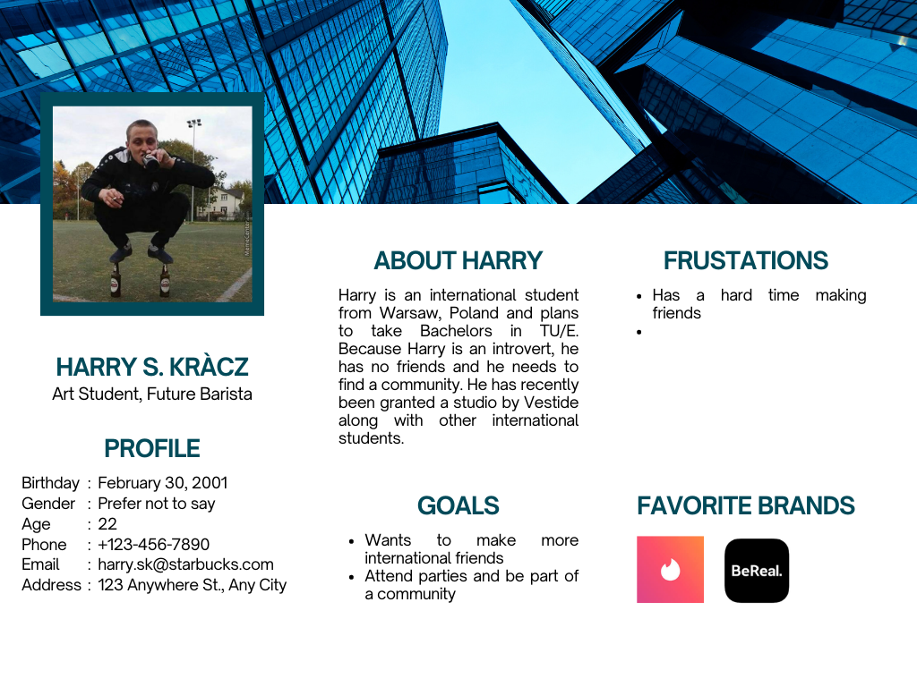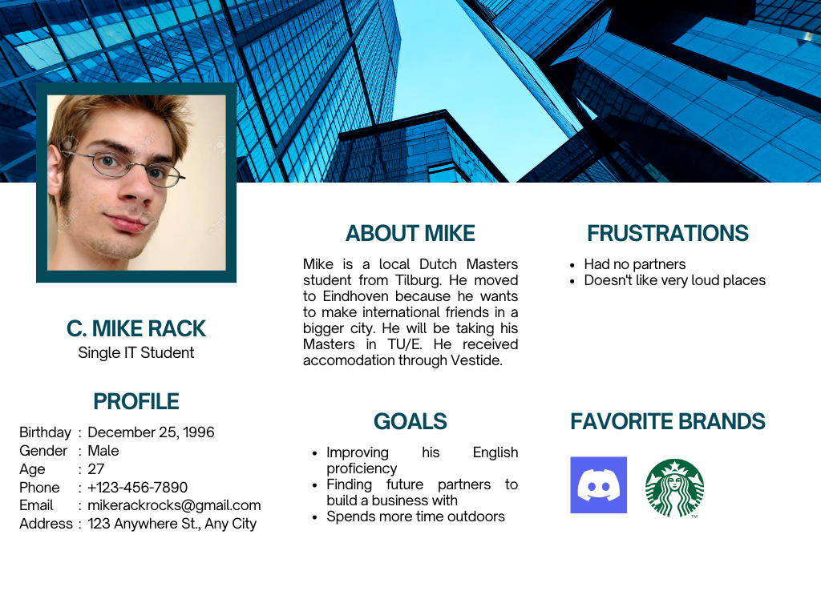

## User stories

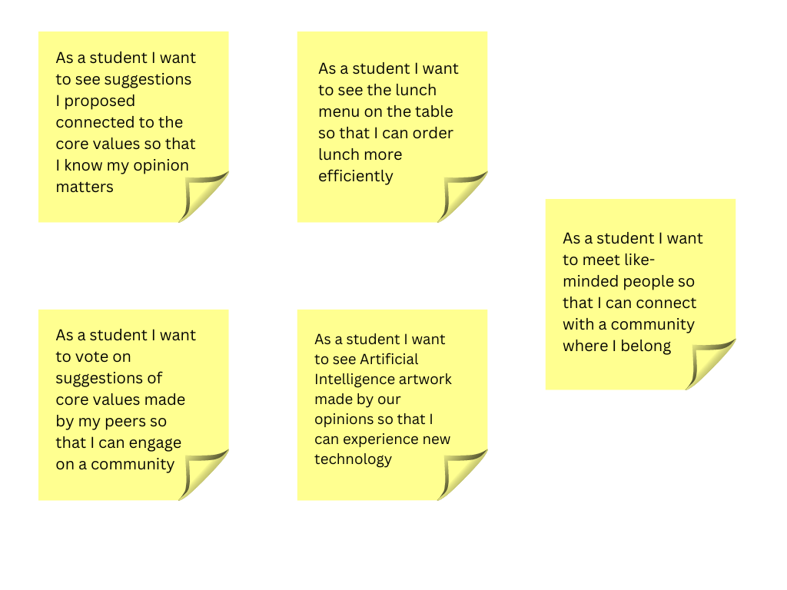

# App design - wireframes

Multiple wireframes designs for the interactive tool have been created, to quickly generate ideas for the final design. From the thinking process, two different UI designs came out of it:

* A standard clear square/ rectangle design commonly found in other interactive tools.
* A diamond-shaped design for the components to make the interface more eye-catching for passerby.

Additionally, a wireframe for the suggestion voting is created for the mobile app. It has a squared design to fit best with smaller screens.

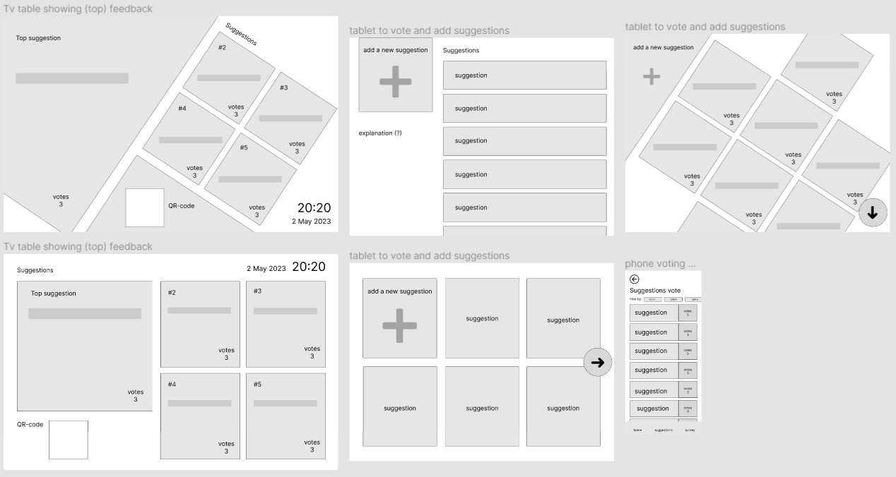

Wireframes have also been created for the AI images display of:

* Just displaying the image.
* Image with a contour border to emulate an actual art display.
* Image with a contour border and short description underneath to give context of the image to the viewer.

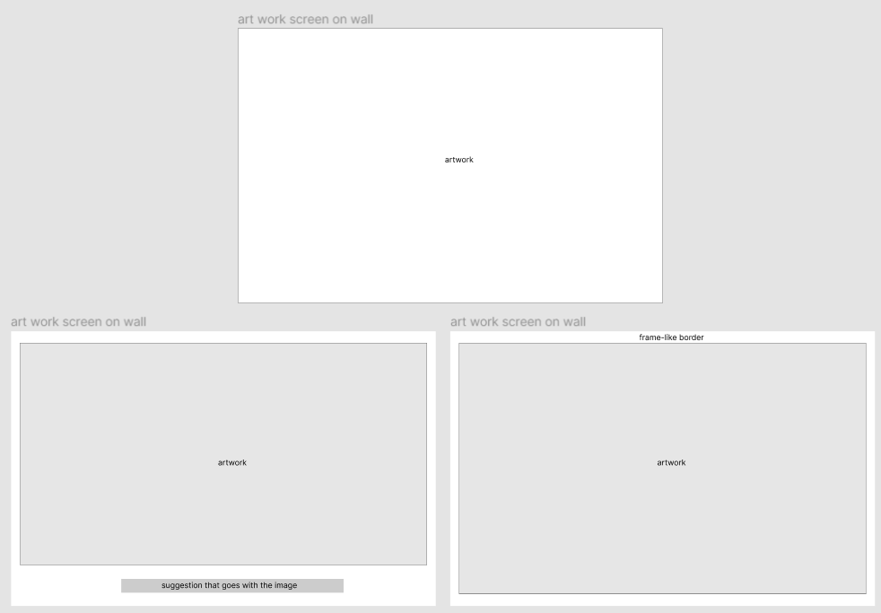

# App design - prototype

A prototype has been built to demonstrate the concept in a digital, interactive system. The system comes in two kinds: the interactive table, and a mobile app.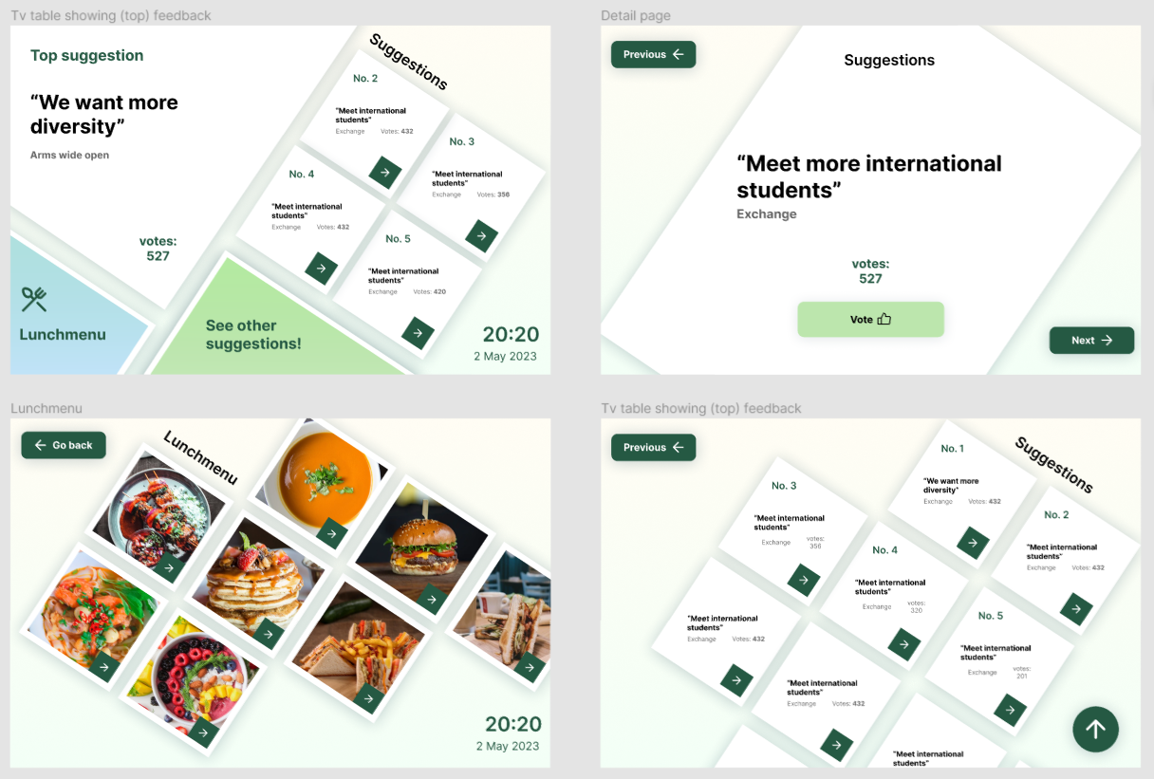

The main color used is green, which is often associated with sustainability and education, which is very fitting for a project pertaining to students and the environment. The overall color scheme is a light pastel to be more personal, and reflect a sense of calmness.

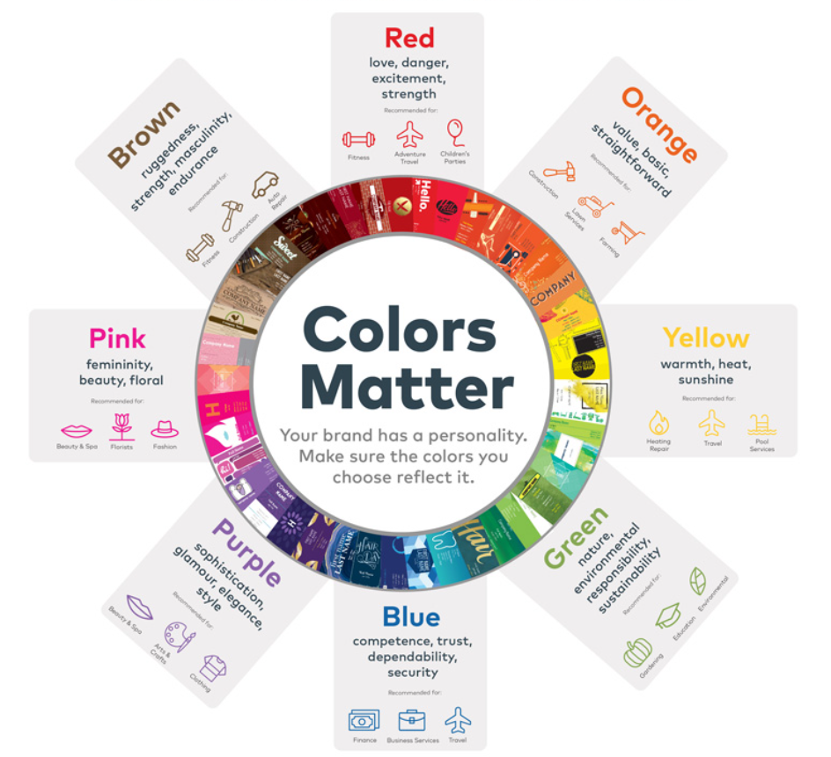

The mobile app's colour scheme is roughly the same as the interactive TV. Aside from displaying suggestions from the LOT community, the app will also feature AI generated images based on the survey responses from users. These images are also displayed on TV screens, creating an exhibition-like atmosphere within the LOT facilities.

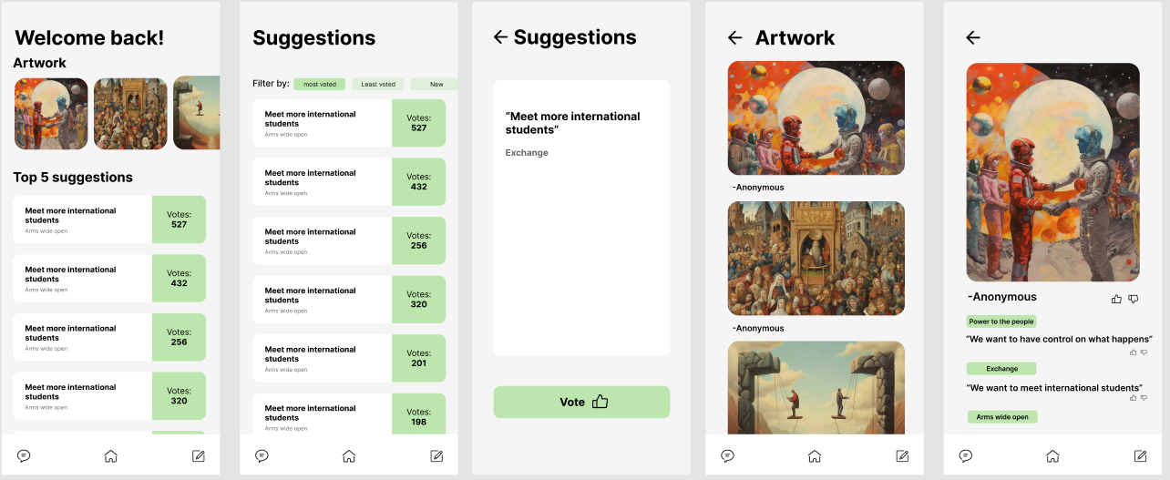

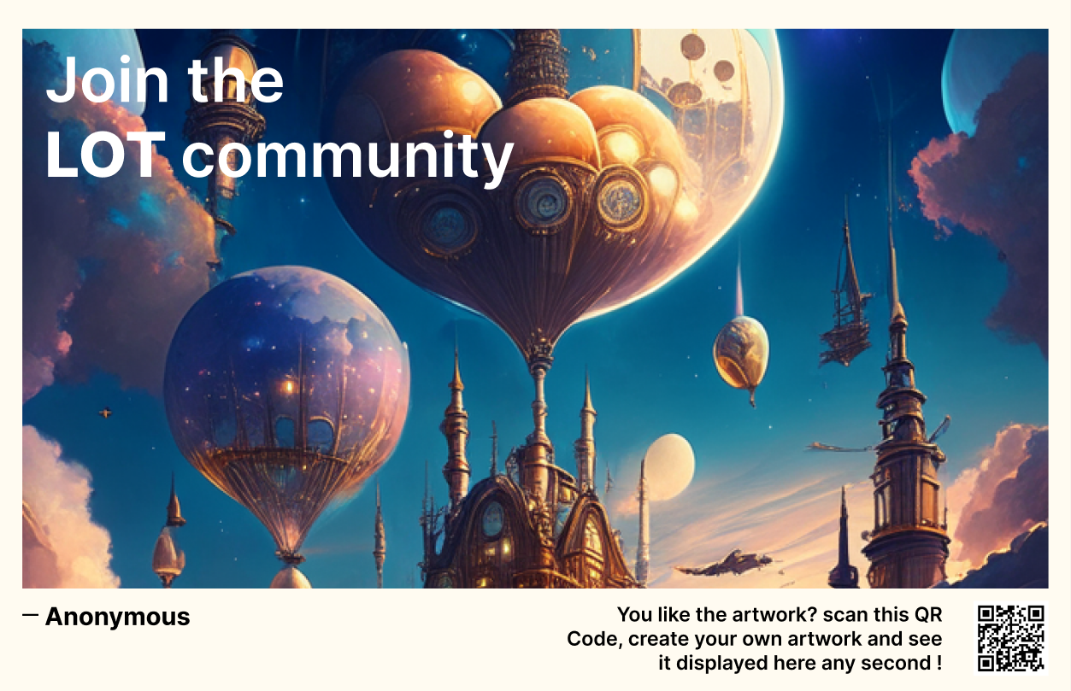

# Building design

To connect the LOT community, we’ve decided to create a space where students can come together. By installing interactive tables with touch displays we animate the people to share their feedback after taking the order. The images that depict the feedback are projected on displays spread throughout the café. The design of the building is sustainable due to it consisting of three recycled containers. On top of the café there is a terrace to come together and enjoy drinks in the sun.

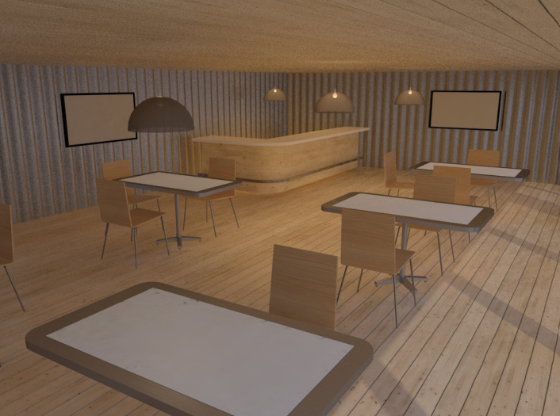

Inside the cafe, with tablet-embedded tables